**Student management system**

1. First of all it asks user the size of array (number of students)

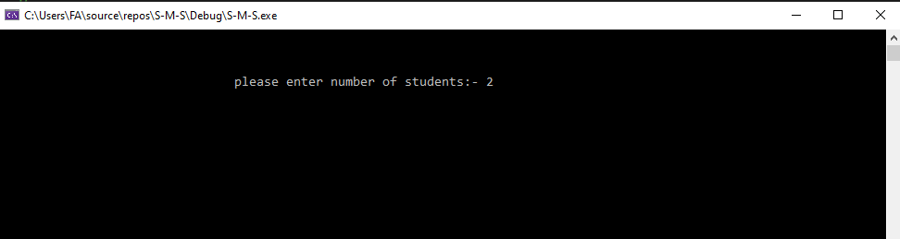

1. Then it asks the data of students (student 1).

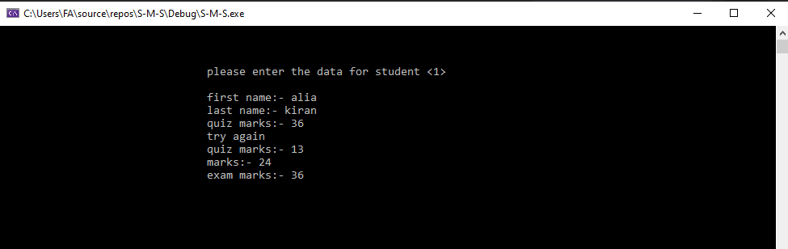

1. Then it asks the data of students (student 2).

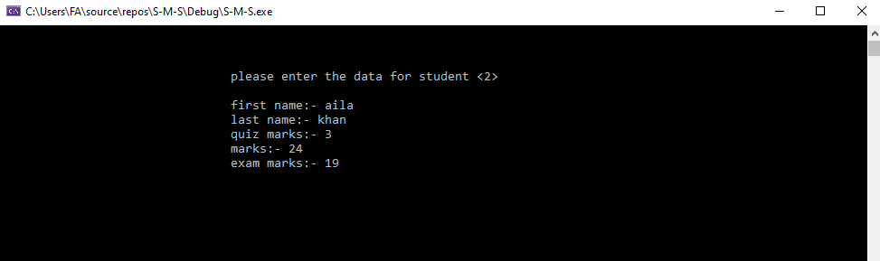

1. Then it shows menu to user.

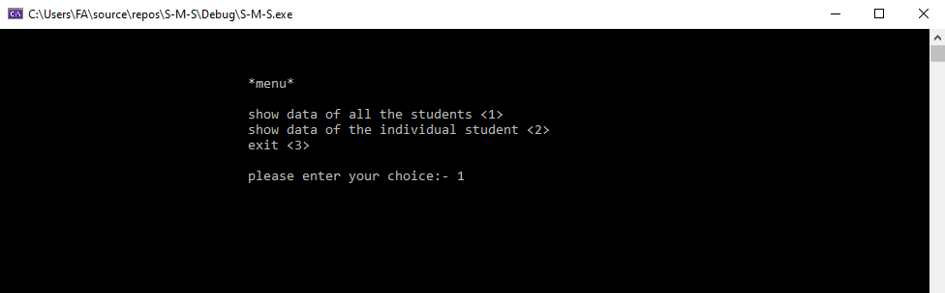

1. If user enters 1 so, it prints all data.

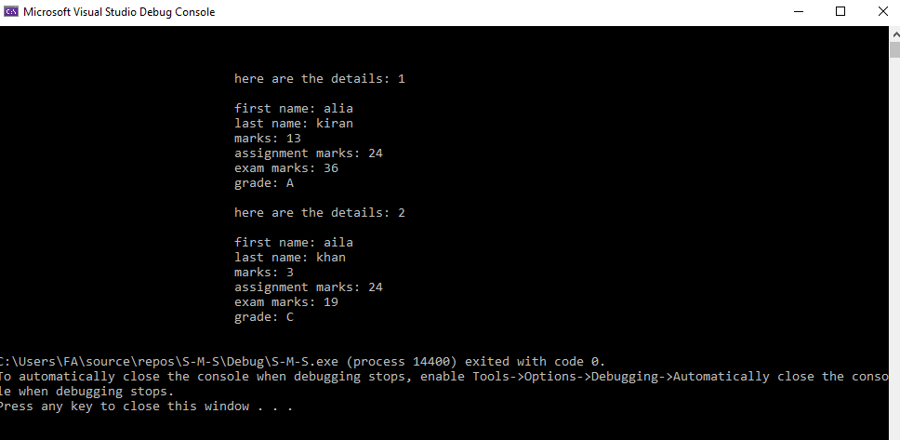

1. if user enters 2 so,

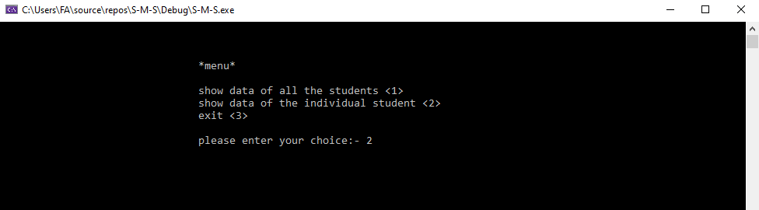

1. it asks user whom data he wants to see.

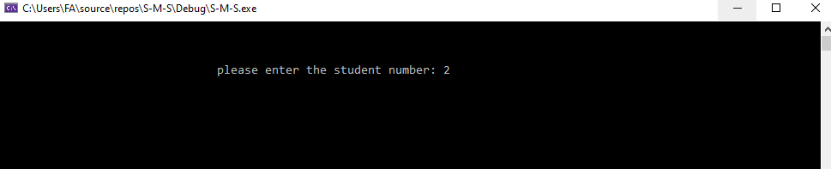

1. then user inputs student number so program print out his data.

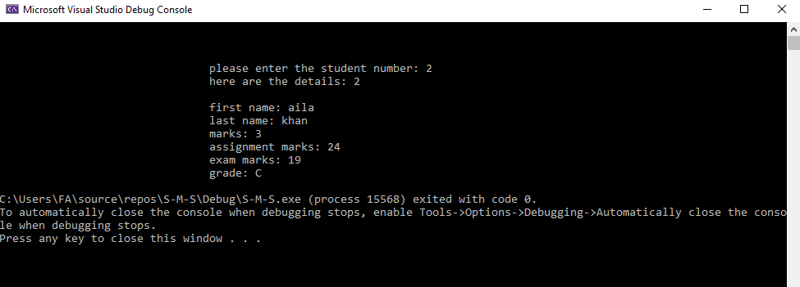

1. in case if user input 4 then,

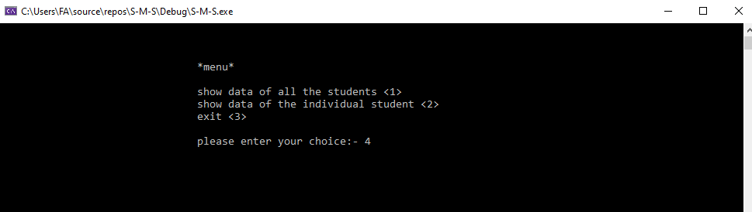

1. it again asks user to input choice because 4 is not in menu.

If user inputs 3 then,

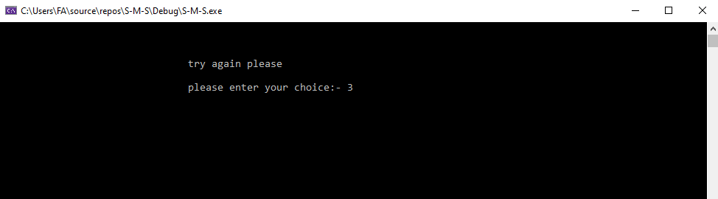

1. it exits the program.

